**Husayn Kassai: Securing Customers Identity with Machine Learning**

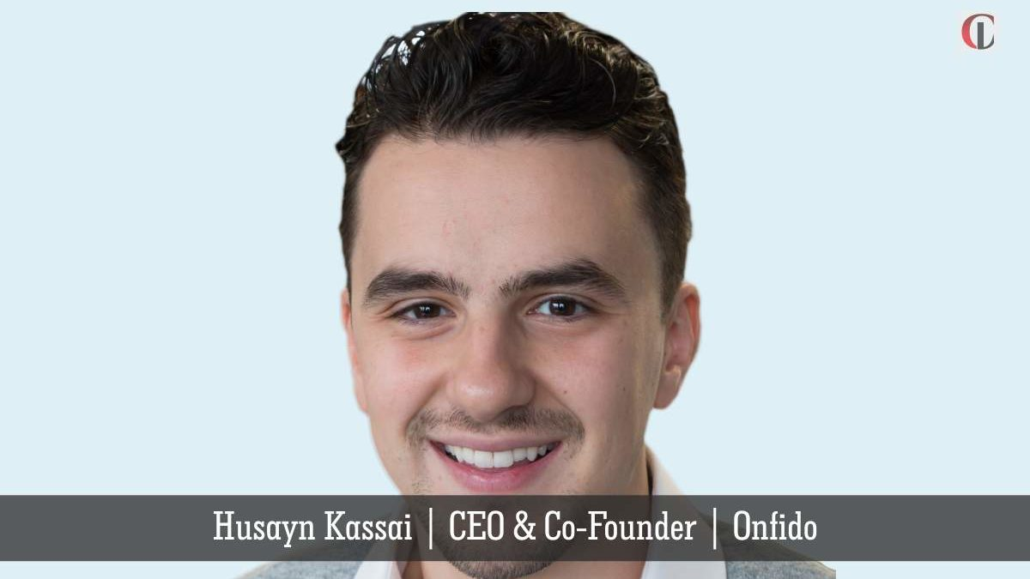

Tackling security-oriented issues has always been difficult for organizations to deal with. Though digitization has almost taken over most sectors, identification recognition systems are still frozen in an offline world. **[Husayn Kassai, CEO](https://is.gd/WIT5E6" \t "_blank)**[and](https://is.gd/WIT5E6" \t "_blank)**[Co-Founder](https://is.gd/WIT5E6" \t "_blank)**[at](https://is.gd/WIT5E6" \t "_blank)**[Onfido](https://is.gd/WIT5E6" \t "_blank)**, has been implicating machine learning to deliver next-generation identity verification.

*Below are the highlights of an interview conducted between* [*CIO Look*](https://ciolook.com) *and Husayn:*

**Give a brief overview of your role in the company and how do you diversify your tech solutions that appeal to your target audience?**

Onfido’s machine learning technology verifies an ID document, and uses facial recognition to compare a selfie-photo or video with the photo on the ID, be it a passport, a driving license or a national ID card. The identity can then be cross-referenced against international credit and watch-list databases*.*

The company supplies several identity verification solutions. These include our *Document Check*, which ensures that users’ identity documents have not been forged, digitally tampered with, lost or stolen, and *Facial Check*, which compares the photo on a user’s identity document with a selfie to make sure users are who they claim to be. The technology enables organizations to perform checks on over 6000 document types detecting anomalies automatically, and using human experts to verify outliers.

Read more:<https://is.gd/WIT5E6>